4065CEM Portfolio Exercise 1
Academic year 2020/2021

Read me 1st

This activity is part of the coursework portfolio for this module. You must do portfolio exercises in the order provided. Ensure each activity is completed prior to attempting the next one. Ideally students should work in groups of two or three.

1. Basic connectivity

As part of this activity students are required to connect the computers with networking devices using the Cisco Packet Tracer.

1.1 Connect a PC to a console port of a router

For this exercise you need to establish a link between the serial port of a PC and a console port of a router in the equipment. To achieve this you will need deploy a roll-over (also known as console) cable to connect from the PC to the console port of the router.

Below list the settings of the serial communication:

Bits per-second: | 9600
Data-bits: | 8
Parity: | no parity
Stop bits: | 1
Flow control: | no flow control

If the connection was successful, a command prompt or a login request should appear on the PC. Please provide screenshot(s) as the evidence of your achievement.

Evidence-1
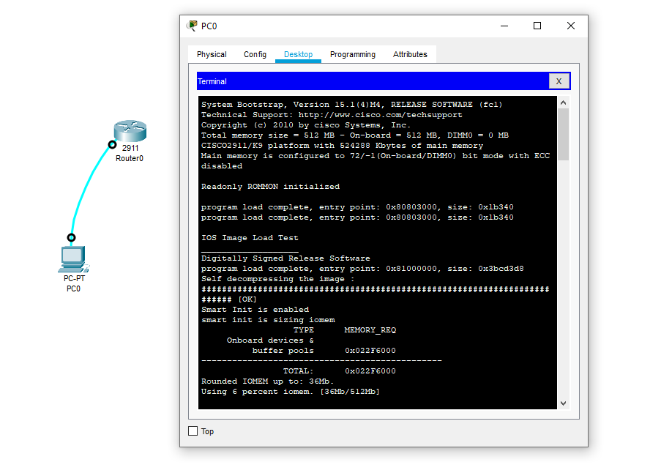

1.2 Simple point to point network between two PCs

Set up a simple point to point network by direct connection using a crossover cable to connect the Ethernet adaptors of the two PCs together. Configure the PCs using the following addresses, where X is selected so that PC1 and PC2 don’t share the same IP address:

IP address for PC 1: 192.10.2.X
IP address for PC 2: 192.10.2.X
Subnet mask: 255.255.255.0

To complete this task you need to evidence via screeshots that:

- The PCs are configured properly by typing “ipconfig” in the command prompt.
- The PCs can communicate with each other by “pinging” PC1 from PC2 and vice versa using the “ping <ip address of other PC>” command in the command prompt.

Evidence-2
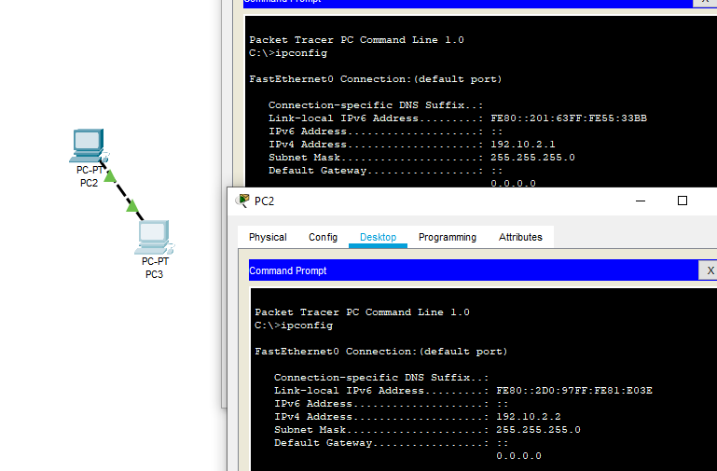

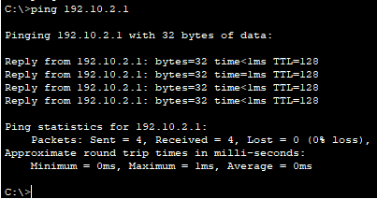

1.3 Simple network using a hub/switch
Set up a simple network using a hub/switch via the Cisco Packet Tracer,
Please demonstrate to the instructor that your network works as you did in the previous exercise (use the same IP addresses as in 1.2), and further provide the evidences of your work as shown below:
- Please provide, as evidence, the screenshot(s) of your system on the Cisco Packet Tracer.

Evidence-3
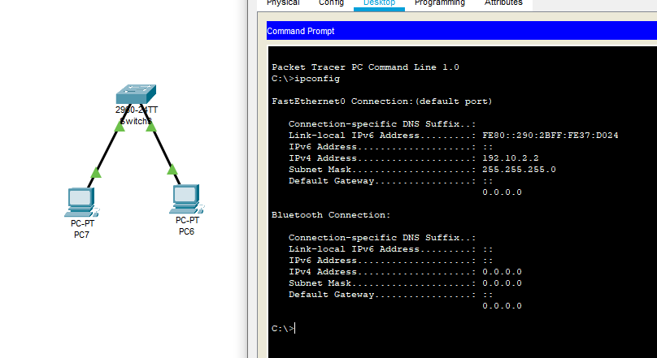
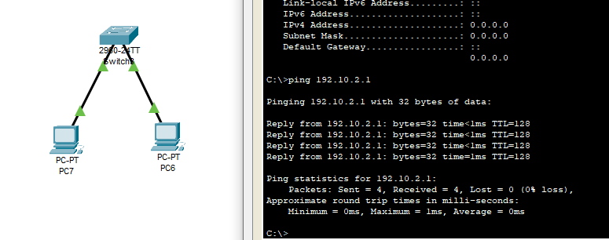

- Please fill in the diagram provided.
Note: Please fill in the missing information in the following diagram – this will be marked and needs to be submitted alongside the reset of the portfolio exercises.

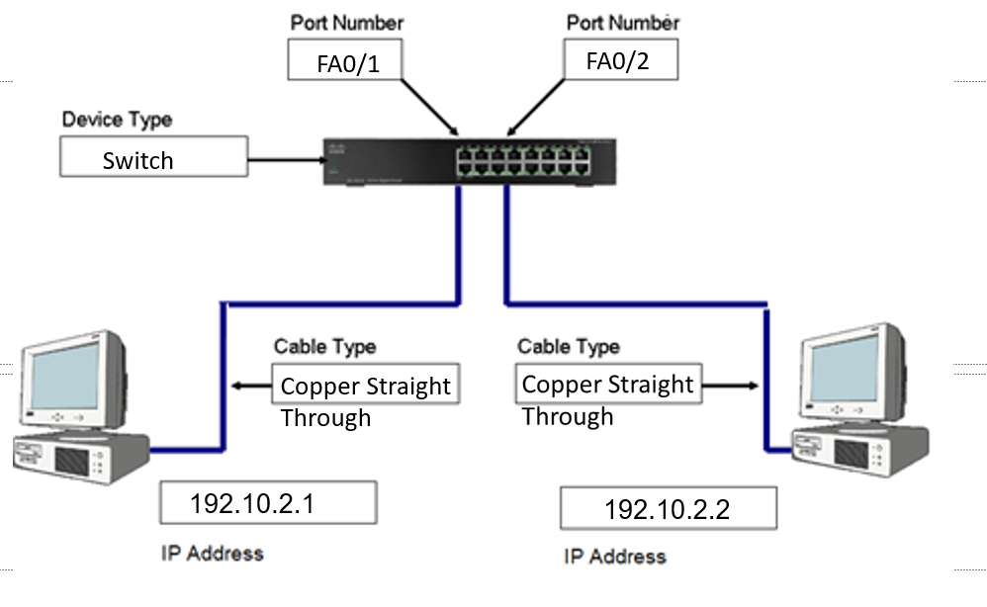

Wiring Diagram for Activity 3 – Please fill in the gaps

Portfolio Submission

You are required to provide the evidence and fill in the portfolio exercise sheets. Those are to be submitted later (all portfolio exercises to be submitted together) as indicated in the coursework description. The completion level and correctness of the submitted portfolio exercise sheets contributes towards you mark.

4065CEM Portfolio Exercise 2
Academic year 2020/2021

Read me 1st

This activity is part of the coursework portfolio for this module. You must do portfolio exercises in the order provided. Ensure each activity is completed prior to attempting the next one. Ideally students should work in groups of two or three.

1. Addressing Scheme

As a network administrator you are required to design the addressing scheme for the network shown in diagram 1. Subnet the given address (192.168.10.0/24) using normal (as opposed to variable) subnet masking and assign a subnet to each part of the network. Finally decide which IP address will be allocated to each port of each device.

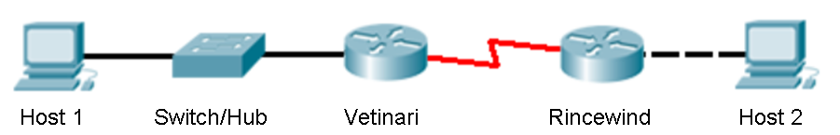

Diagram 1: The Network

  - Subnets: Calculate the subnets and fill in the table below. Remember that for this exercise you are only allowed to use normal subnetting.

No | Subnet | First host | Last host | Broadcast | Subnet mask
1 | 192.168.10.32 | 192.168.10.33 | 192.168.10.62 | 192.168.10.63 | /27
2 | 192.168.10.64 | 192.168.10.65 | 192.168.10.94 | 192.168.10.95 | /27
3 | 192.168.10.96 | 192.168.10.97 | 192.168.10.126 | 192.168.10.127 | /27
4 | 192.168.10.128 | 192.168.10.129 | 192.168.10.158 | 192.168.10.159 | /27
5 | 192.168.10.160 | 192.168.10.161 | 192.168.10.190 | 192.168.10.191 | /27
6 | 192.168.10.192 | 192.168.10.193 | 192.168.10.220 | 192.168.10.221 | /27

  - Device IP addresses: Decide which subnet will be allocated to each network part, and allocate IP addresses to device ports.

Device | Port | IP address | Subnet mask
Vetinari | Ethernet 0/0 | 192.168.10.33 | /27
Vetinari | Serial 0/2/0 | 192.168.10.65 | /27
Rincewind | Ethernet 0/0 | 192.168.10.97 | /27
Rincewind | Serial 0/2/0 | 192.168.10.66 | /27
Host 1 | Ethernet | 192.168.10.34 | /27
Host 2 | Ethernet | 192.168.10.98 | /27

2. Cabling

For this task you are required to wire up the devices in the way illustrated by the network diagram (diagram 1). As this is similar to what we did in the portfolio 1 exercise, step by step instructions will not be provided. However the following few bullet points provide some additional help.

- The link between the two routers (Vetinary and Rincewind) is a serial cable – one side has to be the DCE, meaning that it will provide the clock rate. Connect the DCE side (should be labelled as such) to Rincewind.

- Routers are specialised computers and as such, a crossover cable must be used for a direct computer to router connection (such as the one between Host 2 and Rincewind).

In addition to the network connections shown in diagram 1 we also need two extra connections for the purpose of configuring the routers. For those two connections you are required to connect from the serial port of the computer (not the Ethernet port) to the console port of the router (from Host 1 to Vetinari, and from Host 2 to Rincewind). Detailed instructions of how to do this were given as part of the first portfolio exercise.

After finishing cabling, please provide screenshot(s) as the evidence of your achievement.

Evidence 1:

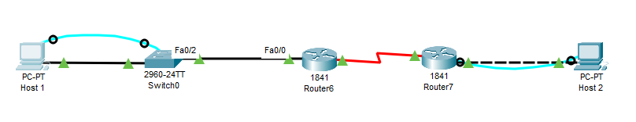

3. Basic router commands

Assuming that the last part of the previous task was completed successfully you should be able to access the router prompt using the Serial port on a PC.

Cisco routers provide a number of different modes (states). Depending on those modes there are different things you can or can’t do. The initial mode is called the user-Exec mode and provides only a limited set of commands. This mode is indicated by using the character “>” as part of the prompt. For instance:

Router>

Typing “?” in the prompt should display a list of the commands available. Typing the name of a command followed by “?” displays the parameters this command expects. Copy some of the commands available along with the explanations provided in the following table.

 | Command | Function
1 | Connect | Open a terminal connection
2 | Disable | Turn off privileged commands
3 | Disconnect | Disconnect an existing network connection
4 | Enable | Turn on privileged commands
5 | exit | Exit from the EXEC
6 | Logout | Exit from the EXEC
7 | Ping | Send echo messages
8 | Ssh | Open a secure shell client connection

To do anything useful we need access to the privilege mode (basically akin to logging in to a computer as admin). We can do that using the enable command. Type “enable” and press enter. If a password is asked for use either “cisco” or “class”. If successful the prompt should change somehow, with the character “#” shown to indicate we are in privilege mode.

Router#

Type “?” to see the commands available to you now (the list should be longer). Copy some of those and their explanations to the table provided.

 | Command | Function
1 | Auto | Exec level automation
2 | Clear | Reset functions
3 | Clock | Manage the system clock
4 | Configure | Enter configuration mode
5 | Connect | Open terminal connection
6 | Copy | Copy from one file to another
7 | Debug | Debugging functions
8 | Delete | Delete a file

The configuration of the router is stored in the startup-config file. When booting the router it is copied to memory. Typing “show running-config” in the privilege mode displays the current configuration the router has loaded in its memory (note that since it might have been changed since the router last booted, the running-config is not necessarily the same as the startup-config). Try this command and inspect the configuration (pressing space to go to the next page). What sort of useful information can be found there?

We can see information of the router such as hostname, if it has an ip address, its interface and what its connected to e.g., FastEthernet0/0. Shows all types of interfaces on the router.

Before we start configuring routers it is a good idea to delete the previous configuration. Type “erase startup-config” to delete the configuration file from the secondary storage. Then restart the router using the “reload” command. After reboot the router might ask you if you want to enter the initial configuration dialog. Answer NO to this question.

Some tips: Writing enough characters for the command to be uniquely identified is enough – “sh run” will work just as well as “show running-config”. Pressing the tab character while typing a command will try to guess what you are trying to type and complete the command for you. The up and down arrow keys allow you to access commands previously typed – so no need to type the same command again and again.

4. Basic router configuration

Before you start this part make sure that the router has no previous configuration set. This can be achieved by erasing the startup-config and reloading the device (last part of the previous task). For this part you are required to configure the two routing devices (Vetinari and Rincewind). In order to configure routers you need to be in the router global configuration mode – the prompt will look like this:

Router(config)#

You can achieve that by typing “enable” to get into privilege mode, and then typing “configure terminal” to enter the global configuration mode. Moving back to the previous mode (if you need to do so) can be achieved by typing exit.

4.1 Router names: First task is to configure the router names. This can be easily achieved with the hostname command:

Router(config)# hostname name

Where name is the name of the device (Vetinary or Rincewind depending on which router you are configuring). If successful the prompt should change accordingly (can also verify by typing “exit” to go back to the privilege mode and using the “show running-config” there).

4.2 Interfaces: The next part is configuring the router interfaces. This can be accomplished by entering interface configuration mode from the global configuration mode and using the “IP address” command followed by the address and subnet mask you wish to configure. Use whatever IP address and subnet masks you assigned to these interfaces in the first part of the exercise. Write those down on the blank spaces provided in the following command sequences.

// Ethernet port for Vetinari:
Vetinari(config)# interface fa0/0
Vetinari(conf-if)# ip address 192.168.10.33 255.255.255.224
Vetinari(conf-if)# no shutdown

// Ethernet port for Rincewind:
Rincewind(config)# interface fa0/0
Rincewind(conf-if)# ip address 192.168.10.97 255.255.255.224
Rincewind(conf-if)# no shutdown

// Serial port for Vetinari:
Vetinari(config)# interface s0/0/0
Vetinari(conf-if)# ip address 192.168.10. 65 255.255.255.224
Vetinari(conf-if)# no shutdown

// Serial port for Rincewind:
Rincewind(config)# interface s0/0/0
Rincewind(conf-if)# ip address 192.168.10.66 255.255.255.224
Rincewind(conf-if)# clock rate 56000
Rincewind(conf-if)# no shutdown

Notice that the above command sequences make some assumptions regarding router port names. Those might not be entirely accurate. You can find out exactly how many ports each router has and how they are called (s0/2/0 or s0/0 or whatever) by typing the “show protocols” command in the privilege mode. For instance:

Vetinari# show protocols

This command is also useful for troubleshooting as it will tell you if the router ports are now operational or not (in which case check you cabling).

4.3 Setting up passwords: Clearly in a real environment we do not want unauthorised personnel been able to change our configurations. The following commands can be used to setup some basic security in our routers. Apply them to both Vetinari and Rincewind.

// Passwords for telnet session (enter line configuration mode)
Router(config)# line vty 0 4
Router(config-line)# password cisco
Router(config-line)# login

// Console and privilege mode passwords
Router(config)#enable password cisco
Router(config)#enable secret class

After you finish you might want to inspect the router’s running config files again in order to see the changes.

Please provide the result of “show running-config” as the evidence of your achievement.

Evidence 2-1
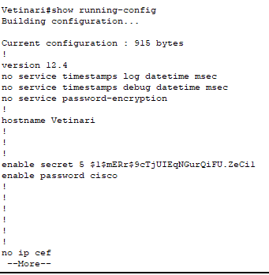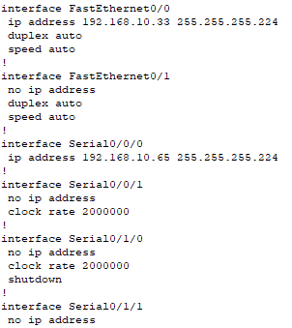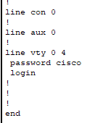

Please provide the result of “show protocols” as the evidence of your achievement.

Evidence 2-2

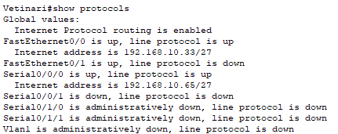

5. Making it all work

It is time to configure the hosts and the routing protocol on the routers and test our network. We start by configuring the two hosts.

5.1 Configuring the computers: Setup the IP address for the two hosts (like you did for the first exercise) and use the “ipconfig” command in the DOS prompt (start->run-> cmd). Note that the default gateway for the two hosts will be the IP address for the Ethernet port of the router they are connected to (if I do not know where a network is, then I send the message to the router).

After you configured the computers try to ping your default gateway from each host. Was it successful?

-No, it says request timed out and all packets were lost.

Now try to ping the other host on the other end of the network. Was it successful?

-No, says the same thing.
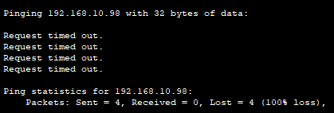

Note that you can also use the ping command in the privilege mode of the routers. Try to ping the serial port of Vetinari from Rincewind and vice versa. Was it successful?

-yes, it was successful.
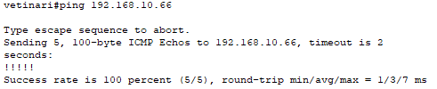

5.2 Configuring RIP: It is time to configure the routing protocol so that routers can exchange information about networks with each other. We are going to use the RIP routing protocol for this exercise. Type “show ip route” on the privilege mode of each router. What is the output of this command?

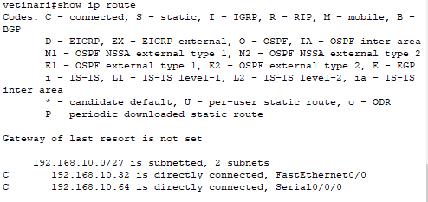

Each router has a number of networks directly connected to it (it knows about them as they are connected to its own interfaces). Those are the networks it needs to advertise to other routers, therefore the ones that should be used when configuring the routing protocol. Use this info to fill in the gaps provided in the instruction sequences that follow.

Vetinari(config)# router rip
Vetinari(config-router)# no auto-summary
Vetinari(config-router)# network 192.168.10.32
Vetinari(config-router)# network 192.168.10.64

Rincewind(config)# router rip
Rincewind(config-router)# no auto-summary
Rincewind(config-router)# network 192.168.10.64
Rincewind(config-router)# network 192.168.10.96

Type the “show ip route” command in the privilege mode again. What has changed (if nothing you done something wrong)?

There is now 3 subnets instead of 2 as shown in this screenshot below.
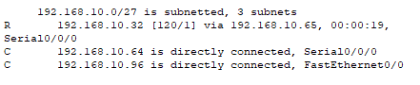

6. Testing the network

At this point the network should be fully operational. In order to verify it we need to make a number of tests.

6.1 Ping Host 1 from Host 2 and vice versa.

Please provide screenshot(s) as the evidence of your achievement.

Evidence 3
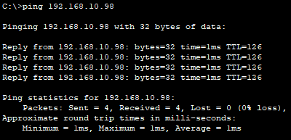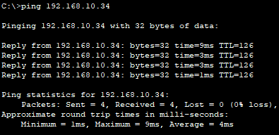

6.2 Ping both host from each router.

SUCCESS

Please provide screenshot(s) as the evidence of your achievement.

Evidence 4
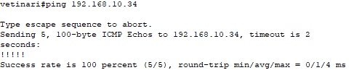
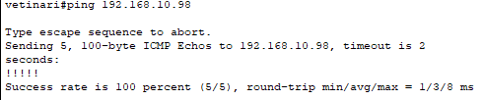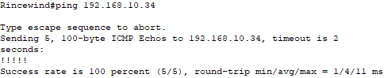
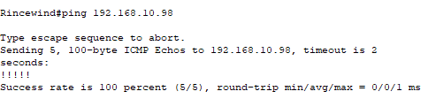

6.3 Trace the route from host 1 to host 2 from the command prompt (tracert xx.xx.xx.xx) command (replace x with the host 2 IP address).

…………………………………………………………………………………………………..
Please provide screenshot(s) as the evidence of your achievement.

Evidence 5
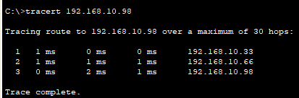

6.4 Telnet to Vetinari from Host 2

………………………………………………………………………………………………......
Please provide screenshot(s) as the evidence of your achievement.

Evidence 6
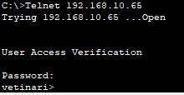

After you finish you might want to save the configurations for the devices to a flash drive for future reference. You can either do so by cut and pasting the output of the show run command to notepad or by using the capture facility offered by the HyperTerminal application. You might also want to reload (reboot the router) in order to erase your work and restore the router to factory settings.

4065CEM Portfolio Exercise 3
Academic year 2020/2021

Read me 1st

This activity is part of the coursework portfolio for this module. This particular activity does not need to be signed off – the router configurations and screenshots that demonstrate end to end connectivity need to be submitted instead. You must do portfolio exercises in the order provided. Ensure each activity is completed prior to attempting the next one. Ideally students should work in groups of two or three.

The Problem

As a first grade technician for the mining company Red Dwarf you have been assigned with the task of designing the addressing scheme for their network (see diagram). In order to do so you have to subnet the network 192.168.42.0/24 ensuring that there will be enough addresses to accommodate the needs of each department. Note that the network connects to the outside world through network 172.17.0.0/16 – you can choose an IP address for this connection (ISP’s IP is 172.17.0.1) but it has to be within the same address space.
Lister
Rimmer
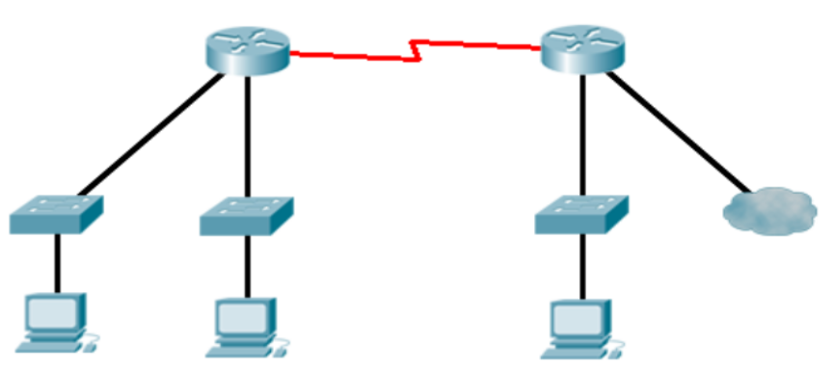
ISP
Officers
(28 Hosts)
Scavengers
(72 hosts)
Canaries
(49 hosts)
172.17.0.1/16

Network Diagram

1. Addressing Scheme

Design the addressing scheme for the network above using VLSM subnet masking. You are allowed to use subnet zero.

 | Subnet | First host | Last host | Broadcast | Mask
Router link | 192.168.42.4 | 192.168.42.1 | 192.168.42.2 | 192.168.42.3 | 255.255.255.252
Officers | 192.168.42.162 | 192.168.42.163 | 192.168.42.191 | 192.168.42.192 | 255.255.255.224
Canaries | 192.168.42.94 | 192.168.42.95 | 192.168.42.144 | 192.168.42.145 | 255.255.255.192
Scavengers | 192.168.42.224 | 192.168.42.255 | 192.168.42.266 | 192.168.42.267 | 255.255.255.128

2. Basic Configuration

For this task you are required to connect the devices using the appropriate cables and configure the interfaces. The commands to do that can be found in the previous portfolio exercise.
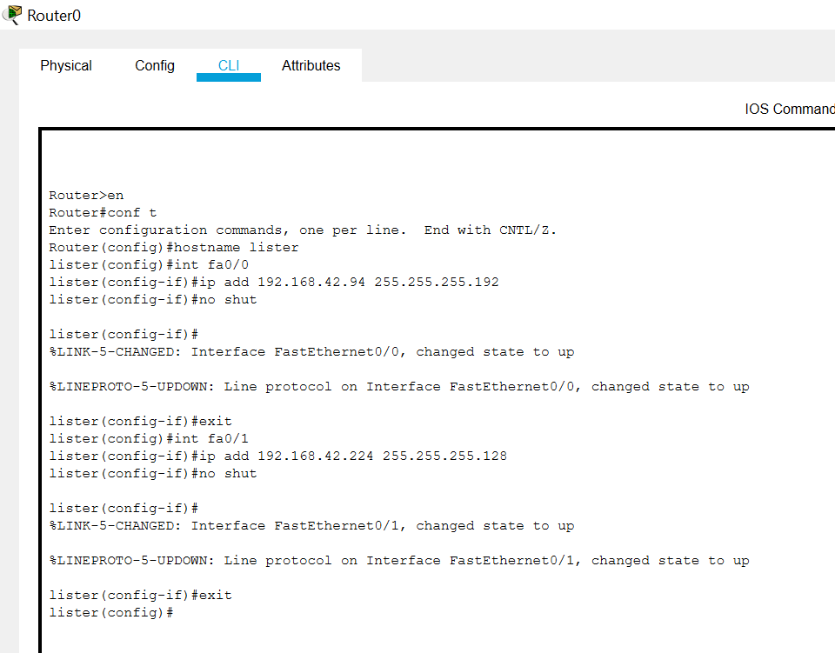

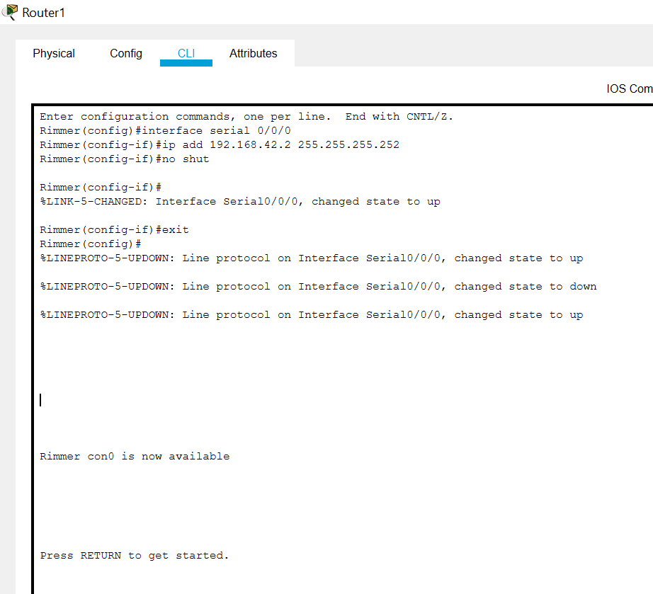

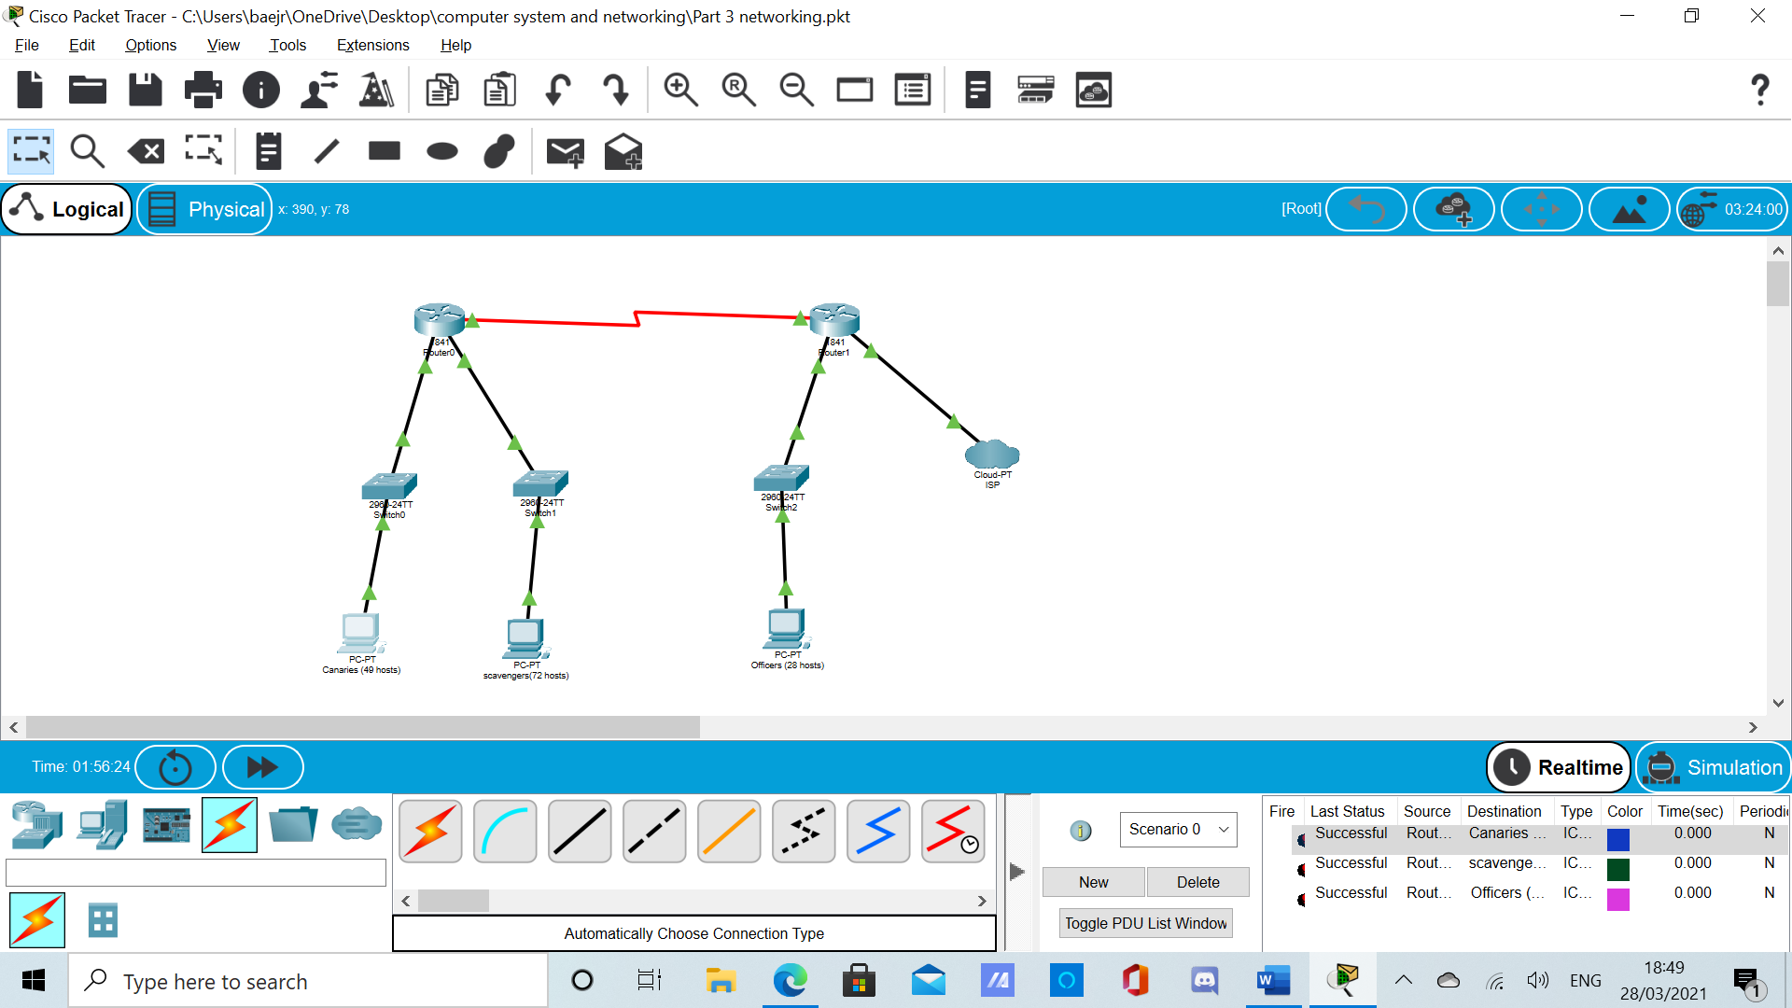

3. EIGRP

EIGRP routing protocol configuration is similar to that of RIP (see portfolio 2) but at the same time differs in a number of significant ways. Routers can support multiple instances of this protocol running at the same time, forming different autonomous systems. As such a positive number must be specified when configuring. This number has to be the same for all routers participating to that autonomous system (and thus can exchange information about the networks that form this system).

Router(config)# router EIGRP number

Another difference is that EIGRP expects hosts bits to be specified when adding networks during the routing protocol configuration. Host bit are indicated using a wildcard mask. Inverting the bits of the subnet mask can be used to derive the wildcard mask for each subnet. For instance: network 192.168.177.128 with subnet mask 255.255.255.192 will have 0.0.0.63 as its wildcard (192=11000000₂ while 63=00111111₂). This network could be added to the list of networks the router advertises using the following instruction:

Router(config-router)# network 192.168.177.128 0.0.0.63

Configure the EIGRP protocol for both routers and verify that the configuration using the “show ip route” command and/or pinging addresses in other, not directly connected parts of you network.

Lister
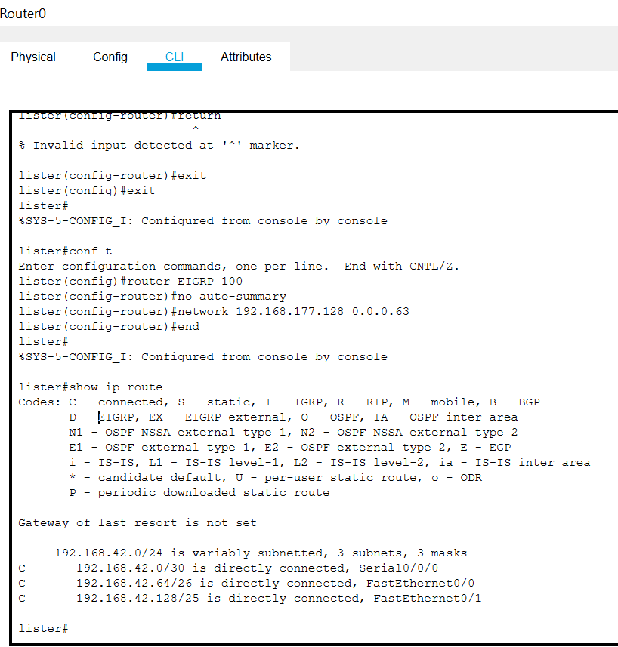

Rimmer
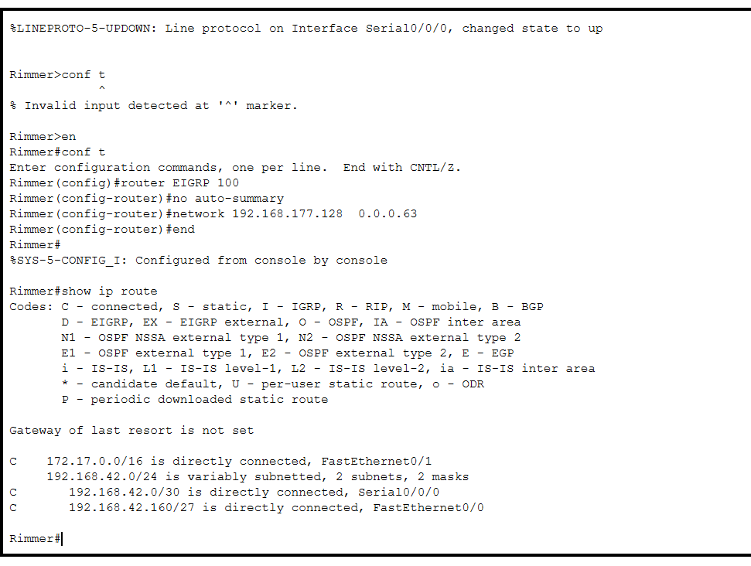

4. Static route

It is impossible for a router to have an entry for every network out there. A default gateway can be configured on router Rimmer to forward traffic towards unknown networks. This can be specified as a static route which redirects any network (0.0.0.0) with any subnet mask (0.0.0.0) we do not know about out of a particular interface (for instance fa0/1). The command to do that would look a bit like:

Router(config)# ip route 0.0.0.0 0.0.0.0 fa0/1

Following the configuration of that static route you might want to ensure that other routers in you autonomous system know about this route. This can be achieved by adding the “redistribute static” command to your router EIGRP configuration.

Router(config-router)# redistribute static

After configuring the gateway try to device a test to verify that this is working as expected.

Important: You need to submit screenshots that demonstrate connectivity. You can either do so by cut and pasting the output of the show run command to notepad or by using the capture facility offered by the HyperTerminal application. Clearly label the configurations and do not forget to include you addressing scheme as part of your submission.

Group Members

Ideally this task should be completed in groups of two. Groups of three are allowed but not recommended.

Name: Batoul Ejrf Student ID:10185016

Name: Mahin Abdussamad Student ID:10874567

Name: Muhammad Sufian Suleman Student ID: 10238611

Submissions should include:

- Group member composition
- Addressing scheme
- Router configurations (clearly labelled)
- Evidence that end to end connectivity was achieved (i.e. ping and trace route screenshots)

The first subnet can be the one where all network bits are set to zero. This in effect makes the formula giving the number of subnets 2^{n}-1.
Enhanced Internal Gateway Routing Protocol (EIGRP) is a CISCO proprietary vector routing protocol. It supports variable length subnet masking, uses multiple metrics to rate routes and only sends updates when changes are detected. This makes it a better choice than RIP, especially for bigger and more complex networks - EIGRP offers many advanced features, consumes less bandwidth and offers faster convergence (time taken before all routers get updated with the latest information). The main drawbacks of EIGRP are that it is a proprietary protocol not supported by all vendors and that it is more complex than RIP (requiring more effort to implement and more processing power to run).

